Name ______________________________________________ Date _________________
1
The Goal

EDP “IMPROVE” Challenge Activity
Custom Boxed Candies
by STEM Pre-Academy
Description of the Iterative or IMPROVE Challenge:
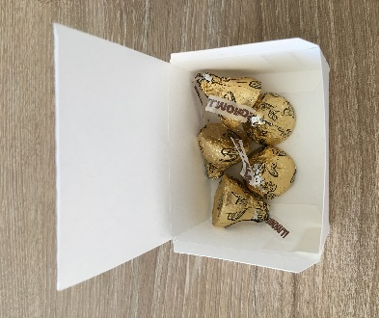
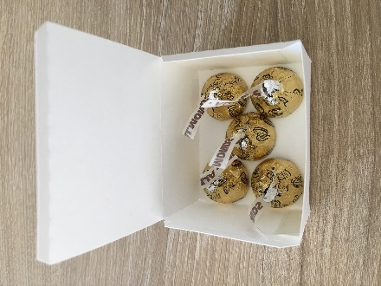
You have been hired to improve the design of a candy box for Kāneʻohe Candy Company. The candy box created by a Product Design Engineer failed to meet one of the customer’s requirements in a demonstration trial. During the demonstration, the customer gently shook the candy box to simulate the jostling that can occur during mail transport. Upon opening the candy box, the candy was found to be in complete disarray. This failed the aesthetic requirement for the candy box.
BEFORE AFTER
Following are the requirements from the customer:
- The candy box should fit five pieces of foiled-wrapped chocolate.
- The candy box must not allow any candy to accidentally fall from the box when opened.
- The candy box design must be aesthetically appealing, both when opened and closed.
- As many filled candy boxes as possible should fit into the company’s shipping box with a minimum of wasted space.

The Iteration or IMPROVE step requires that the candy box be undamaged and aesthetically appealing when a customer opens the shipping box. Listed below are the engineer’s notes:
Materials List:
- Index Cards | - Scotch Tape
- Pipe Cleaners | - Scissors
- Glue Stick | - Exacto Knife (provided to expedite the fabrication for adults)
¹ Engineering is Elementary|Museum of Science, Boston (Image creator). (2016). The engineering design process [Diagram]. Retrieved from http://www.eie.org/overview/engineering-design-process
ASK Step
Ask
Identify Need
Define Problem
”Spec”
Original Problem Statement: The client requires a candy box that can fit 5 pieces of foiled-wrapped chocolate. The candy box design must not allow any candy to fall from the box when opened and be aesthetically appealing, both when opened and closed. The candy box must also fit in a shipping box (8.5 in. x 5 in. x 1.5 in.) and use all the available space to minimize packing material.

Requirements/Specification sheet:
# | Requirements/Specifications | Weight | Justification (Why?)
1 | Five pieces of candy must fit in the candy box | 5 | Based on cost effective production rate required by the customer.
2 | The candy box design must not allow any candy to fall from the box when opened | 5 | Required by the customer. Maintain the high quality standard of the Company.
3 | The candy box design must be aesthetically appealing, both when opened and closed | 3 | Marketing strategy required by the customer.
4 | Use all the available volume in the shipping box (8.5 in. x 5 in. x 1.5 in.). Minimize packing material. | 4 | To minimize packing material. Required by the customer.

IMAGINE Step
Imagine
Alt. Solutions
Background Research
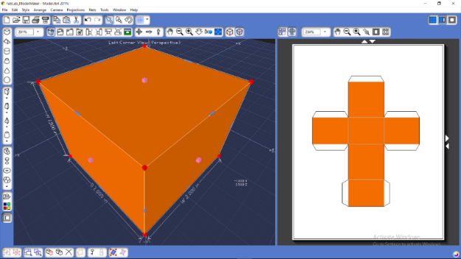
Design # 1:

Note: Tool shown is called the Fab Lab.
Shapes shown are pre-made and take only a few minutes to draw. For more information about this tool please contact STEM Pre-Academy.

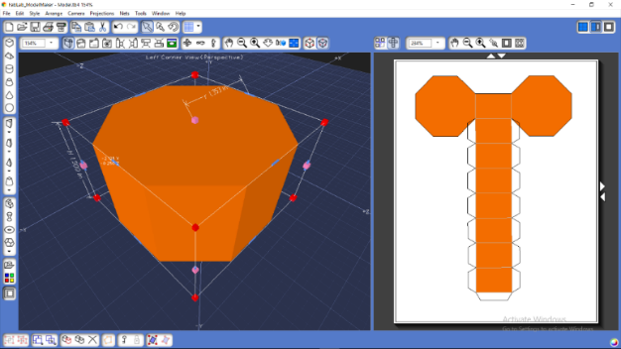
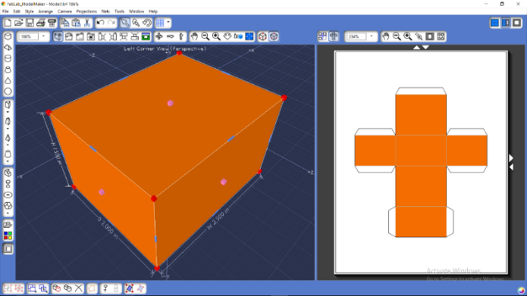
Design # 2: Design # 3:

PLAN Step
Plan
Evaluation Criteria
Model
Optimal Selection

Pugh Chart:
Design Score: Select a score that best describes the Requirement/Specification. The Weight is the maximum score, 0 is the lowest score. The design that best satisfies the Requirement/Specification shall be given a higher score.
# | Requirements/Specifications | Weight | Design #1  Score | Design #2  Score | Design #3  Score
1 | Five pieces of candy must fit in the candy box | 5 | Yes (5) | Yes (5) | Yes (5)
2 | The candy box design must not allow any candy to fall from the box when opened | 5 | No (0) | No (0) | No (0)
3 | The candy box design must be aesthetically appealing, both when opened and closed | 3 | Yes (2) | Yes (3) | Yes (1)
4 | Use all the available volume in the shipping box (8.5 in. x 5 in. x 1.5 in.). Minimize packing material. | 4 | No (0) | Yes (4) | No (0)
 |  | TOTAL | 7 | 12 | 6

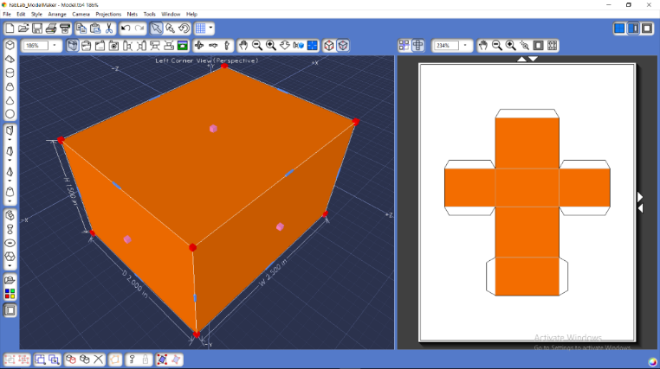
Design #2 is selected because it scored the highest (12 points).

Specifications:
Length = 2.5 in.
Width = 2.0 in.
Height = 1.5 in.
Number of packages inside shipping box (8.5 in. x 5 in. x 1.5 in.) = 8
Candies per package = 5

Create
Simulate
Prototype
Implement
CREATE Step

# | Requirements/Specifications | Pass / Fail
1 | Five pieces of candy must fit in the candy box | Pass
2 | The candy box design must not allow any candy to fall from the box when opened | Fail
3 | The candy box design must be aesthetically appealing, both when opened and closed | Pass
4 | Use all the available volume in the shipping box (8.5 in. x 5 in. x 1.5 in.). Minimize packing material. | Pass

START OF THE ACTIVITY
Improve
Test
Evaluate
Communicate

IMPROVE Step

Your task is to take the current prototype and improve it in order to satisfy all of the requirements. Please re-examine the previous prototype and make the necessary adjustments. Limited supplies have been provided for your use. Good luck improving The Kāneʻohe Candy Company’s candy box design!

Imagine
Alt. Solutions
Background Research
IMAGINE Step (2)

Problem Statement: The client requires a candy box that can fit 5 pieces of foiled-wrapped chocolate. The candy must be secured in the box so, it will look appealing when opened and closed. The box must also fit in a shipping box (8.5 in. x 5 in. x 1.5 in.) and use all the available space to minimize packing material.

Design # 2A:

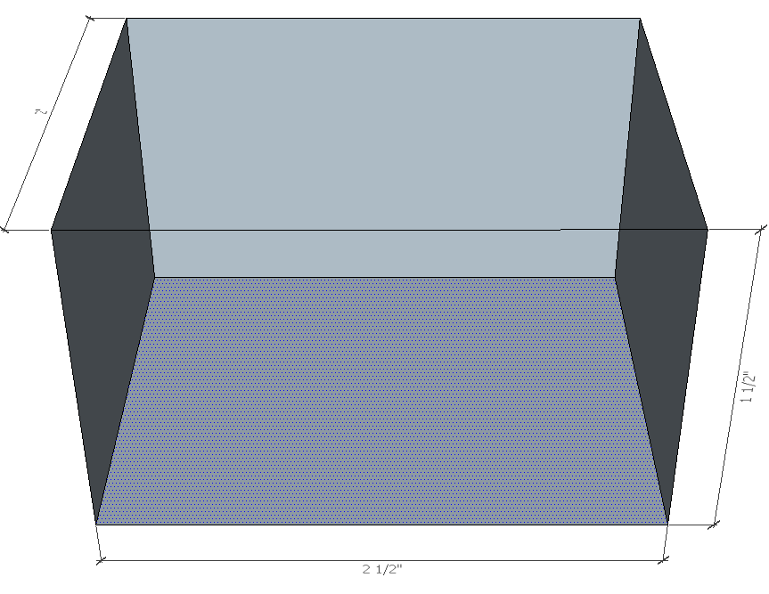

View: Bottom of the Box 3D View of Box

Design # 2B:

View: Bottom of the Box 3D View of Box
Plan
Evaluation Criteria
Model
Optimal Selection
PLAN Step (2)

Design Score: Select a score that best describes the Requirement/Specification. The Weight is the maximum score, 0 is the lowest score. The design that best satisfies the Requirement/Specification shall be given a higher score.
# | Requirements/Specifications | Weight | Design # 2A | Design # 2B
1 | Five pieces of candy must fit in the candy box | 5
2 | The candy must be secure in the candy box so it will look appealing when open. (Test: you must flip the candy box around 1 time) | 5
3 | The candy box design must be aesthetically appealing, both when opened and closed | 3
4 | Use all the available volume in the shipping box (8.5 in. x 5 in. x 1.5 in.). Minimize packing material. | 4
 |  | TOTAL

Create
Simulate
Prototype
Implement

CREATE Step (2)

# | Requirements/Specifications | Pass / Fail
1 | Five pieces of candy must fit in the candy box
2 | The candy must be secure in the candy box so it will look appealing when open. (Test: you must flip the candy box around 1 time)
3 | The candy box design must be aesthetically appealing, both when opened and closed
4 | Use all the available volume in the shipping box (8.5 in. x 5 in. x 1.5 in.). Minimize packing material.

